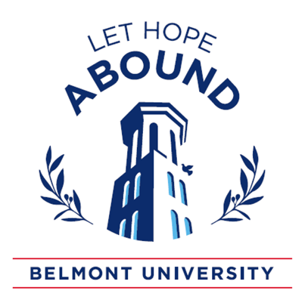
Values for BASIC Proposal
Development

Core Concept: Enthusiasm without knowledge is not good.

Key Quote:
“The [Haiti] aid story is one of good intentions and bad policy, short-term fixes without a ground-breaking long game, Band-Aids over self-sufficiency.” – Jonathan Katz

Three Primary Postures

ONE: MUTUALITY — Do with, not for.
- Relational rather than transactional
- Limit one-way giving to crisis situations
- Get the right people in the planning process (particularly those being served)
- Prioritize needs of those with whom we will work
- Consider power dynamics at play

TWO: HUMILITY — We all have something to learn.
- Seek to lay down impulse to be hero
- Move from “Savior” mentality to “Servant” mentality
- “Superiority disguised as a desire to serve is still superiority…” – Duane Elmer in Cross Cultural Servanthood

THREE: PATIENCE — Build capacity, not dependency.
- Long-term development takes longer than we expect
- The goal is eventually to not be needed
- Consider the Oath for Compassionate Helpers when moving quickly

Oath for Compassionate Helpers
- I will seek not to do for others what they have the capacity to do for themselves.
- I will limit one-way giving to crises and seek always to find ways for legitimate exchange.
- I will seek ways to empower by hiring, lending, and investing and offer gifts sparingly.
- I will put the interests of those experiencing poverty above my own (or organizational) self- interests, even when it means setting aside my own agenda.
- I will listen carefully, even to what is not being said, knowing that unspoken feelings may contain essential clues to healthy engagement.
- Above all, to the best of my ability, I will do no harm.

